Python String Case Methods:
A Comparative Technical Analysis of str.title() and str.capitalize()
Faculty of Artificial Intelligence — Menoufia University
Data Science Fundamentals | 2025–2026
Abstract
Python's built-in string library provides two superficially similar methods for capitalizing text: str.title() and str.capitalize(). Despite their apparent similarity, these methods differ fundamentally in their scope of operation, treatment of non-initial characters, word boundary detection, and behavioral edge cases. Incorrect substitution of one for the other is a common source of subtle bugs in text processing pipelines, data cleaning workflows, and natural language preprocessing. This paper provides a rigorous, example-driven comparison of both methods, covering their formal specifications, internal character-level behavior, delimiter sensitivity, known quirks (particularly the apostrophe edge case in str.title()), recommended use cases, and practical workarounds. A comprehensive decision guide, edge case catalogue, and reference implementation examples are provided to equip practitioners with the knowledge to select the correct method for every string formatting scenario.

1. Introduction
String manipulation is among the most frequent operations in Python programming, appearing in data preprocessing, natural language processing, web development, report generation, and user interface design. Python's str class provides a rich set of case-transformation methods — among them upper(), lower(), title(), and capitalize(). Of these, title() and capitalize() are particularly prone to confusion because both produce strings that begin with an uppercase letter, yet their behavior diverges significantly across a wide range of inputs.
The core distinction can be stated concisely: str.capitalize() treats the entire string as a single unit and capitalizes only its very first character, lowercasing all others. str.title() treats the string as a sequence of words delimited by any non-alphabetic character and capitalizes the first character of each such word, leaving non-initial characters unchanged. This difference, while simple to state, has non-trivial consequences for inputs containing uppercase letters, apostrophes, hyphens, underscores, digits, and other special characters.
This paper is organized as follows: Section 2 reviews Python's string model. Section 3 specifies str.title() formally. Section 4 specifies str.capitalize() formally. Section 5 provides a comprehensive side-by-side comparison. Section 6 details edge cases and known quirks. Section 7 discusses use-case guidance. Section 8 presents workarounds for common pitfalls. Section 9 concludes.

2. Python String Model

2.1 String Immutability
In Python, strings are immutable sequences of Unicode code points. Every string method — including title() and capitalize() — returns a new string object; the original is never modified. This immutability has two important implications: (1) the methods are safe to call in any context without side effects, and (2) the return value must be explicitly captured.
s = "hello world"
s.title() # Returns "Hello World" — s is unchanged
result = s.title() # Correct: capture the result

2.2 Unicode Awareness
Both methods operate on Unicode strings and handle non-ASCII characters according to Unicode case folding rules. The definition of "alphabetic" is Unicode-aware: characters such as 'é', 'ñ', 'ü' are treated as alphabetic and will be subject to capitalization. Non-alphabetic Unicode characters (digits, punctuation, emoji) serve as delimiters for title() and are passed through unchanged by both methods.

2.3 Available Case Methods
Python's str class provides four primary case-transformation methods:
- str.upper() — converts all characters to uppercase.
- str.lower() — converts all characters to lowercase.
- str.title() — title-cases the string (first char of each word uppercased).
- str.capitalize() — capitalizes only the first character; lowercases all others.
- str.casefold() — aggressive lowercasing for case-insensitive comparisons (handles German ß, etc.).
This paper focuses exclusively on the comparison between title() and capitalize(), as these are the most commonly confused pair.

3. str.title() — Specification and Behavior

3.1 Formal Definition
According to the Python documentation: "Return a titlecased version of the string where words start with an upper case character and the remaining characters are lower case." More precisely, str.title() scans the string left-to-right and applies the following rule to each character:
- If the character is alphabetic AND immediately follows a non-alphabetic character (or is the first character of the string), uppercase it.
- Otherwise, leave it unchanged.

3.2 Word Boundary Detection
A critical aspect of str.title()'s behavior is its definition of a "word boundary." Unlike human intuition or NLP tokenizers, Python's title() considers any non-alphabetic character as a word separator. This includes:
- Whitespace: " ", "\t", "\n" — expected word boundaries.
- Hyphens: "-" — treats hyphenated compounds as multiple words: "well-known" → "Well-Known".
- Underscores: "_" — treats snake_case as multiple words: "snake_case" → "Snake_Case".
- Digits: "0"–"9" — digits reset the "word boundary" flag: "2fast" → "2Fast".
- Apostrophes: "'" — this is the most surprising case: "it's" → "It'S" — discussed in detail in Section 6.
>>> "hello world".title()
"Hello World"
>>> "HELLO WORLD".title()
"HELLO WORLD" # Non-initial chars left unchanged!
>>> "well-known fact".title()
"Well-Known Fact"

4. str.capitalize() — Specification and Behavior

4.1 Formal Definition
According to the Python documentation: "Return a copy of the string with its first character capitalized and the rest lowercased." The entire string is treated as a single unit. The rule is:
- The first character: if alphabetic, uppercase it; if non-alphabetic, leave it unchanged.
- All remaining characters: convert to lowercase, regardless of position or word boundaries.

4.2 Key Behavioral Properties
The lowercasing of all non-first characters is the defining behavior of str.capitalize() and the primary source of difference from str.title():
>>> "HELLO WORLD".capitalize()
"Hello world" # ALL subsequent chars lowercased
>>> "hello WORLD".capitalize()
"Hello world" # Same result regardless of input case
>>> "123 hello".capitalize()
"123 hello" # First char is digit, unchanged; rest lowercased
>>> " hello".capitalize()
" hello" # First char is space — no capitalization occurs
Note the important edge case: if the string begins with a non-alphabetic character (digit, space, punctuation), capitalize() produces no visible capitalization effect, since the first character cannot be uppercased. The remaining characters are still lowercased.
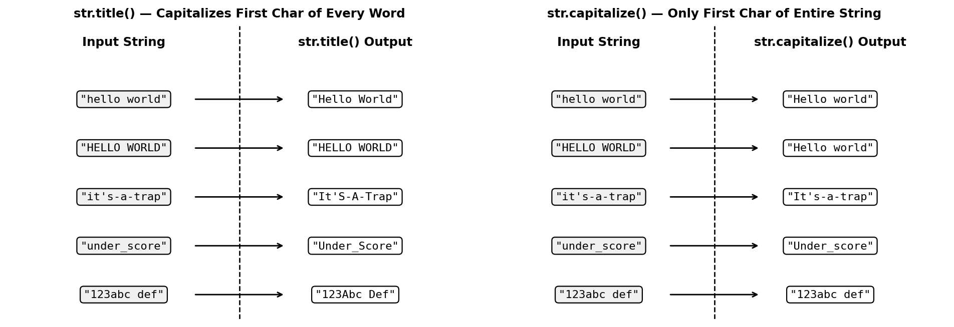
Figure 1. Side-by-side transformation tables for str.title() (left) and str.capitalize() (right) across five representative inputs. Note that "HELLO WORLD" produces different outputs: title() leaves non-initial characters unchanged, while capitalize() lowercases everything after the first character.
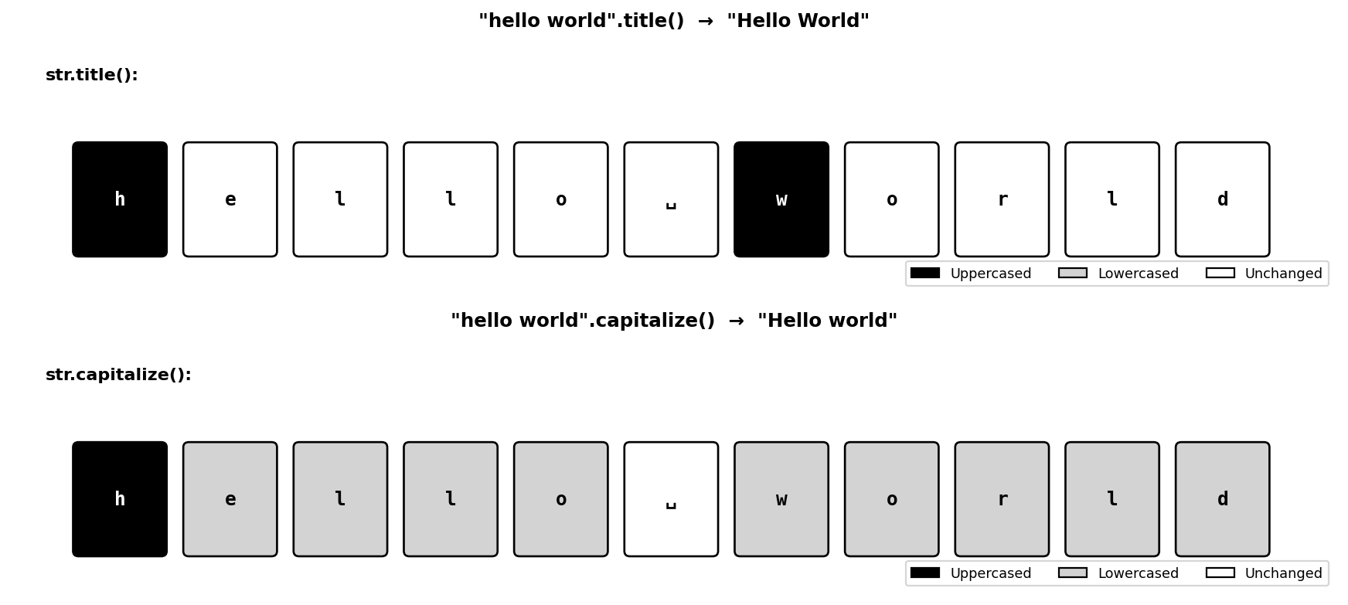
Figure 2. Character-level breakdown of both methods applied to "hello world". For str.title() (top): positions 0 and 6 (first chars of each word) are uppercased (black); all others are unchanged (white). For str.capitalize() (bottom): position 0 is uppercased (black); positions 1–10 (excluding space) are lowercased (gray).

5. Comprehensive Comparison

Criterion | str.title() | str.capitalize()
Scope of capitalization | First character of every word | First character of entire string only
Effect on other characters | Leaves non-initial characters unchanged | Converts ALL other characters to lowercase
Word delimiter handling | Any non-alpha char acts as delimiter (space, hyphen, underscore, digit, apostrophe) | Does not recognize word boundaries at all
Unit of processing | Each word independently | Entire string as one unit
Apostrophe handling | Treats apostrophe as delimiter → uppercases letter after it (quirk) | No special handling — apostrophe unchanged
Input "HELLO WORLD" | "HELLO WORLD" (non-initial chars unchanged) | "Hello world" (lowercases everything else)
Input "hello world" | "Hello World" | "Hello world"
Input "it's fine" | "It'S Fine" ← unexpected uppercase S | "It's fine" ← no word boundary issue
Primary use case | Book/article titles, headings, proper nouns | First word of a sentence, simple names
Python syntax | string.title() | string.capitalize()

6. Edge Cases and Known Quirks

6.1 The Apostrophe Quirk in str.title()
The most widely encountered and surprising behavior of str.title() is its treatment of apostrophes in contractions. Since an apostrophe (') is a non-alphabetic character, title() treats it as a word boundary. The character immediately following the apostrophe is therefore considered the "first character of a new word" and is uppercased:
>>> "it's fine".title()
"It'S Fine" # Unexpected: 's' is uppercased
>>> "don't stop".title()
"Don'T Stop" # Same issue
>>> "o'clock".title()
"O'Clock" # Acceptable in this case
This is not a bug — it is the documented behavior — but it violates the natural expectation for contractions in English text. The issue does not arise with str.capitalize(), which does not attempt word boundary detection.

6.2 Behavior with All-Uppercase Input
The two methods diverge dramatically on all-uppercase input:
>>> "HELLO WORLD".title()
"HELLO WORLD" # Non-initial chars unchanged — stays uppercase!
>>> "HELLO WORLD".capitalize()
"Hello world" # Lowercases everything after first char
This means title() is not idempotent when applied to already-uppercase strings — the result depends on the input case, not just the word structure. If the goal is to normalize an input that might be in any case, capitalize() or a manual lower() + title() pipeline is more appropriate.

6.3 Digit and Special Character Delimiters
Any non-alphabetic character in title() triggers capitalization of the next alphabetic character:
>>> "2fast2furious".title()
"2Fast2Furious" # Each digit triggers a new "word"
>>> "abc123def".title()
"Abc123Def" # Digit triggers capitalization of 'd'
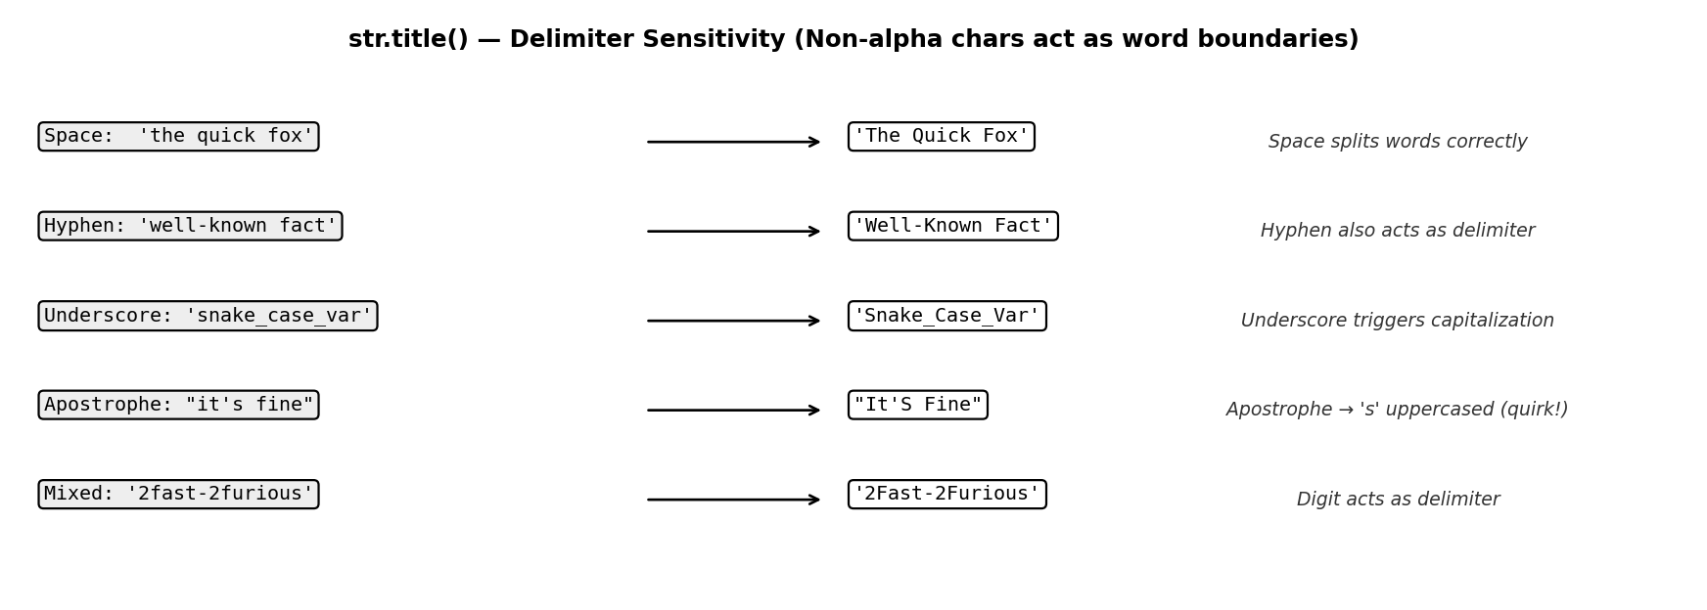
Figure 3. str.title() delimiter sensitivity across five input types. Any non-alphabetic character — space, hyphen, underscore, apostrophe, or digit — acts as a word boundary, triggering capitalization of the immediately following alphabetic character. The apostrophe case (row 4) produces the commonly unexpected "It'S Fine" output.

6.4 Leading Non-Alphabetic Characters
When a string begins with a non-alphabetic character, the methods behave differently:
>>> " hello world".title()
" Hello World" # First alpha char after spaces is capitalized
>>> " hello world".capitalize()
" hello world" # First char is space; no capitalization; rest lowercased
The capitalize() behavior here is particularly subtle: the string is not unchanged — the remaining characters are still lowercased — but because the string already starts with spaces (which are not alphabetic), no visible capitalization occurs. This can lead to silent errors when cleaning strings that may have leading whitespace.

Input | .title() | .capitalize() | Note
"hello world" | "Hello World" | "Hello world" | Standard case
"HELLO WORLD" | "HELLO WORLD" | "Hello world" | .title() leaves non-initials; .capitalize() lowercases all
"it's fine" | "It'S Fine" | "It's fine" | .title() apostrophe quirk — unexpected uppercase
"snake_case" | "Snake_Case" | "Snake_case" | Underscore acts as delimiter only for .title()
"123abc def" | "123Abc Def" | "123abc def" | Digit is delimiter for .title(); .capitalize() needs alpha first char
" hello" | " Hello" | " hello" | .capitalize() skips leading spaces — no effect
"" | "" | "" | Both return empty string safely
"well-known" | "Well-Known" | "Well-known" | Hyphen is delimiter for .title() only

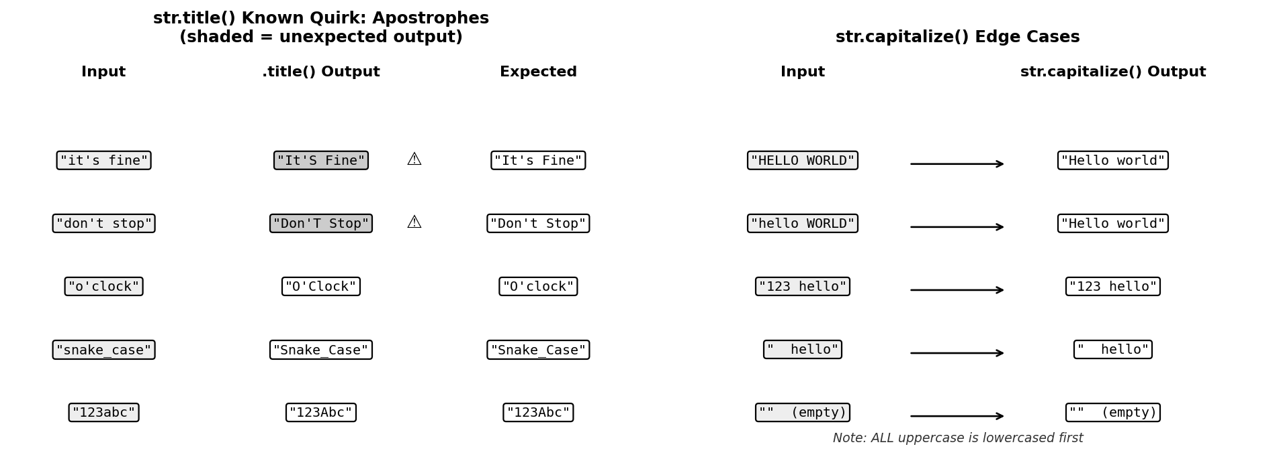
Figure 4. Left: str.title() apostrophe quirk across five inputs — shaded cells indicate unexpected uppercase output (e.g., "It'S Fine"). Right: str.capitalize() edge cases — note that "HELLO WORLD" is fully lowercased except the first character, and strings starting with digits or spaces receive no capitalization.

7. Use-Case Guidance

7.1 When to Use str.title()
str.title() is appropriate when:
- Formatting book, article, or section titles: "introduction to machine learning".title() → "Introduction To Machine Learning"
- Rendering proper noun lists: Names of people, places, or organizations stored in lowercase.
- Display formatting of category labels: Converting database values like "data_science" to "Data_Science" for UI display.
- Column headers in reports: Quick capitalization of programmatically generated header names.
Caution: Do not use title() on text containing contractions (it's, don't, can't) or possessives without being aware of the apostrophe quirk.

7.2 When to Use str.capitalize()
str.capitalize() is appropriate when:
- Capitalizing the first word of a sentence: User-entered text that may be in any case needs sentence-start normalization.
- Normalizing names stored in all-caps: "SMITH".capitalize() → "Smith" — correct for single-word names.
- Formatting error messages or log entries: Ensure the first letter is uppercase regardless of how the message string was constructed.
- Cleaning database fields: When the entire string should be lowercased except for the very first character.
Caution: Do not use capitalize() on multi-word strings when capitalization of each word is desired — it will lowercase all words after the first.
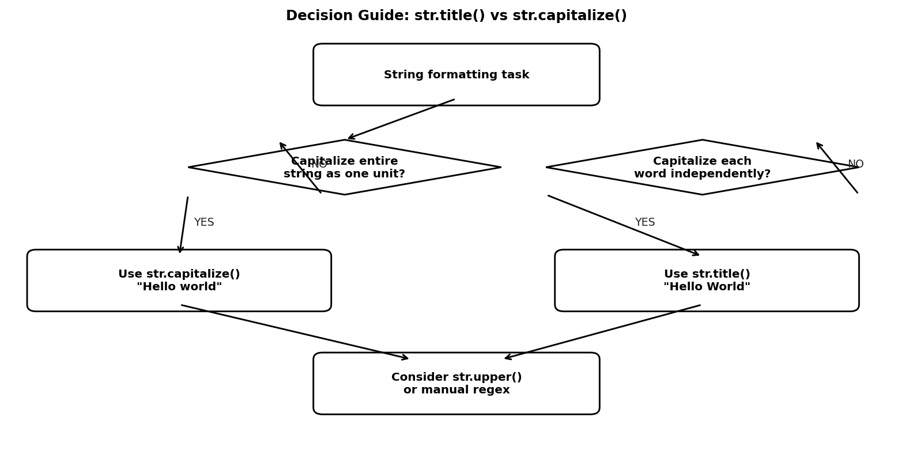
Figure 5. Decision flowchart for choosing between str.title() and str.capitalize(). The key question is the scope: capitalizing the entire string as one unit → capitalize(); capitalizing each word independently → title(). When neither fits (e.g., smart title casing), consider str.upper(), manual regex, or the third-party titlecase library.

8. Workarounds for Common Pitfalls

Goal | Naive approach (problem) | Recommended workaround
Title case without apostrophe quirk | "it's fine".title() → "It'S Fine" ✗ | import re re.sub(r"[A-Za-z]+", lambda m: m.group(0).capitalize(), s)
Capitalize only first word of multi-word string | "hello world".capitalize() → "Hello world" ✓ | str.capitalize() — this is the correct tool
True title case (respect existing caps) | "MacBook Pro".title() → "Macbook Pro" ✗ | Use titlecase library: titlecase("MacBook Pro")
Capitalize every word, lower rest | "HELLO WORLD".title() → "HELLO WORLD" ✗ | " ".join(w.capitalize() for w in s.split())

8.1 Fixing the Apostrophe Quirk in str.title()
The standard workaround for the apostrophe problem is to use a regular expression that splits on spaces only, then capitalizes each token:
import re
def smart_title(s):
return re.sub(r"[A-Za-z]+'*[A-Za-z]*",
lambda m: m.group(0)[0].upper() + m.group(0)[1:],
s)

>>> smart_title("it's a fine day")
"It's A Fine Day" # Apostrophe handled correctly
Alternatively, the third-party titlecase library implements full AP/Chicago style title casing including proper handling of articles, prepositions, and contractions.

8.2 Capitalizing Every Word While Lowercasing Non-Initials
When the goal is to capitalize every word AND lowercase all non-initial characters (which title() does not do for non-initial chars):
s = "HELLO WORLD"
" ".join(word.capitalize() for word in s.split())
"Hello World" # Each word normalized independently

9. Performance Considerations
Both str.title() and str.capitalize() are implemented in CPython's C layer, giving them O(n) time complexity where n is the length of the string. In practice, both methods are extremely fast and will not be the bottleneck in any typical application.
For bulk operations on large datasets (e.g., millions of strings in a pandas DataFrame), use vectorized string methods:
import pandas as pd
df["name"] = df["name"].str.title() # Vectorized
df["name"] = df["name"].str.capitalize() # Vectorized
Pandas' str.title() and str.capitalize() are thin wrappers around Python's built-in methods and carry the same behavioral semantics, including the apostrophe quirk.

10. Conclusion
str.title() and str.capitalize() are both string case-transformation methods in Python, but they operate at fundamentally different scopes and with different treatment of non-initial characters. The key distinctions are:
- Scope: title() processes each word; capitalize() processes the entire string as one unit.
- Non-initial characters: title() leaves them unchanged; capitalize() lowercases them all.
- Word boundaries: title() uses any non-alphabetic character as a delimiter; capitalize() ignores word boundaries entirely.
- The apostrophe quirk: title() uppercases the character following an apostrophe — a documented but frequently unexpected behavior.
The practical guidance is straightforward: use str.capitalize() when formatting the start of a sentence or normalizing a single-word string. Use str.title() when formatting multi-word headings or labels — but be aware of the apostrophe and digit delimiter behaviors. For more precise control, use str.split() with str.capitalize() per token, or the titlecase library for publication-quality title casing.

References
[1] Python Software Foundation (2024). Python 3.12 Documentation: Built-in Types — str.title(). https://docs.python.org/3/library/stdtypes.html#str.title
[2] Python Software Foundation (2024). Python 3.12 Documentation: Built-in Types — str.capitalize(). https://docs.python.org/3/library/stdtypes.html#str.capitalize
[3] Unicode Consortium (2023). Unicode Standard, Version 15.1: Chapter 4 — Character Properties (Case Folding). https://www.unicode.org/versions/Unicode15.1.0/
[4] Lutz, M. (2013). Learning Python, 5th Edition. O'Reilly Media. Chapter 7: String Fundamentals. https://www.oreilly.com/library/view/learning-python-5th/9781449355722/
[5] Ramalho, L. (2022). Fluent Python, 2nd Edition. O'Reilly Media. Chapter 4: Unicode Text Versus Bytes. https://www.oreilly.com/library/view/fluent-python-2nd/9781492056348/
[6] CPython Source Code: Objects/unicodeobject.c — unicode_title_impl(), unicode_capitalize_impl(). https://github.com/python/cpython/blob/main/Objects/unicodeobject.c
[7] Python Stack Overflow Community (2023). "str.title() apostrophe behavior" — Discussion of known quirk. https://stackoverflow.com/questions/1549641/how-can-i-capitalise-the-first-letter-of-each-word-in-a-string
[8] McKinney, W. (2022). Python for Data Analysis, 3rd Edition. O'Reilly Media. Chapter 7: Data Cleaning and Preparation — String Manipulation. https://wesmckinney.com/book/data-wrangling
[9] titlecase library — Stuart Colville (2023). titlecase: Python titlecasing with AP/Chicago style rules. https://pypi.org/project/titlecase/
[10] pandas Development Team (2024). pandas 2.2 Documentation: Working with Text Data — str.title() and str.capitalize(). https://pandas.pydata.org/docs/user_guide/text.html

